Sunday 30th May Nicodemus visits Jesus John 3 v 1-17
Nicodemus was an experienced teacher but even he struggled with what Jesus was saying. When we are first born we have a clean slate, our whole lives ahead of us with so much we can do. It does not take long to fill our lives with the things that we want to begin to plan our days, our weeks and futures! Each day we make choices and fill our lives with all the things that we want to do! When we are born again, it is a brand new start, we choose to live for God instead. We follow Jesus’ example offering our lives to Father God and inviting the Holy Spirit to be our guide.

Why do you think Nicodemus came to visit Jesus at night? What do you think might stop people you know asking questions about God for themselves? Can you think of a time when you were able to share your faith Dear God, with somebody else or answer their questions about God?

Family Game: Wind Race
Jesus described the Holy Spirit like a wind which you can hear but not see. Have your own “wind race” – make balls from crumpled up paper and choose a table or surface to use as a course. You could even set up a course using household objects. Racers should blow the paper balls along the table or round the course and see who can do it the fastest. If there is not much space take it in turns to complete the course and time how long each person takes!

Family Craft: New Creation Butterfly
I am a new creation in Christ! God gives me a brand new life…I have been born again! Re-created… Jesus lets us live eternally! Just like a caterpillar is transformed into a Butterfly, we are transformed by the Holy Spirit
Paint egg carton bodies and let dry, glue googly eyes to the top of the head (facing upward). Use one pipe cleaner to thread through holes in the head to make the antenna.
Print off the butterfly wing template below, cut around the outside line, and decorate with crayons, markers, glitter paint, pom poms.
Staple the two wings together, punched holes in the paper on either side of the body, and thread a pipe cleaner through the holes, around the body, twisting the ends together in back.
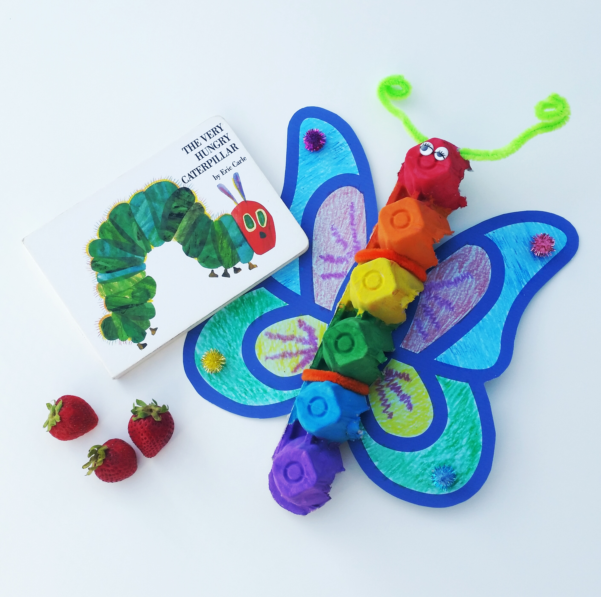
Family Challenge: “Up-cycled and born again”

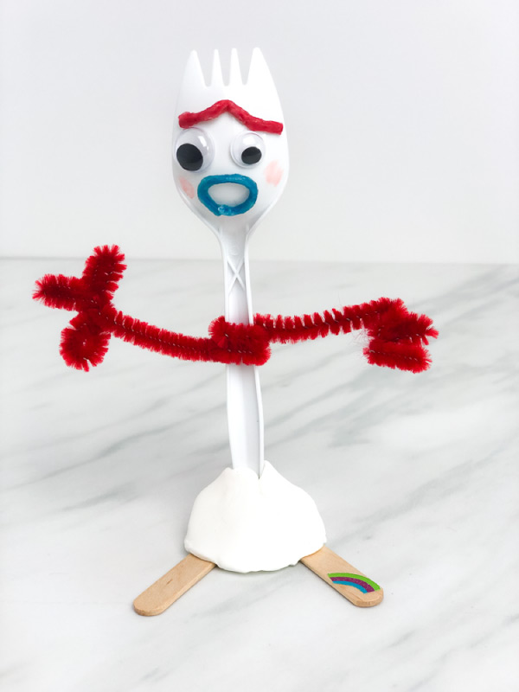
Set out a variety of materials, some for decorating and some for recycling, use your creativity to create new objects out of old ones. Decorate, change, and adapt old materials to be useful new things or just fun! Who can make the best item out of something old. Remember we are all “made new”, too, when we have faith in Christ!
A verse to remember: John 3 v 16
“God loved the world so much that he gave his one and only Son so that whoever believes in him may not be lost, but have eternal life. ”

Prayer:
Dear God, with somebody else or answer their questions about God? Thank you for the story of Nicodemus who wanted to learn more about you. Help us to seek to know you more and to ask questions which help us to learn. This Trinity Sunday help us to come to know all of who you are. Help us to connect with you as our loving parent, our Saviour and our helper guide. Give us wisdom to share what we know about you with others and to answer their questions just like Jesus did. Amen

