Sunday 20th June: The story of David defeating Goliath 1 Samuel 17
How do you think David felt when he went to face Goliath? How would you have felt? The whole of King Saul’s army were scared of Goliath, none of them were brave enough to take on the Philistines greatest warrior. When David went out to meet Goliath he didn’t have any armour on, he didn’t have any impressive weapons, but he had something better – Faith! David knew God, when you read the songs that David wrote about God in the psalms you can tell that he knew God as a close friend. David had faced bears and lions when he was a shepherd and God had always been with him. David trusted in God and knew he didn’t need to be afraid because God was on his side. That is why he could say with confidence in God, “The battle belongs to him, and he will hand you over to us.

Video to watch: https://www.youtube.com/watch?v=Bsup35Xixtk&t=2s

Family Craft: David’s Boulder Shooter!
Need: Paper cup, Balloon, Screwed up paper or pom poms
Cut the bottom of your paper cup, tie your balloon (do not blow up, don’t even be tempted to blow up for fun as this can spoil your balloon), cut the your of your balloon then stretch over the end of the cup, just add your pom poms or paper and fire!

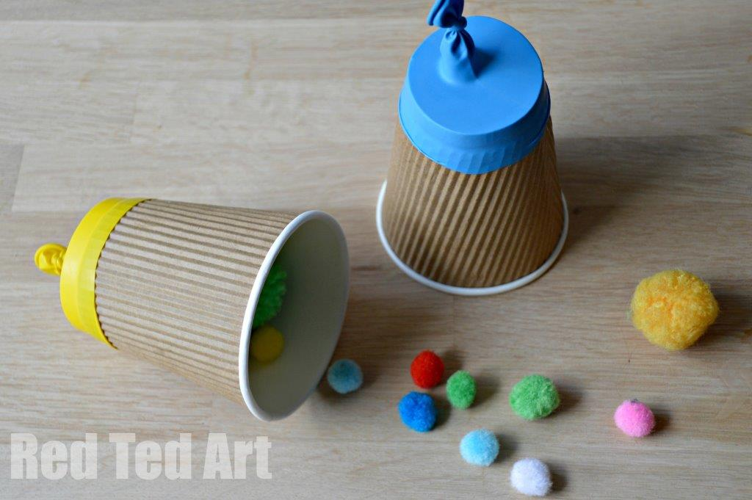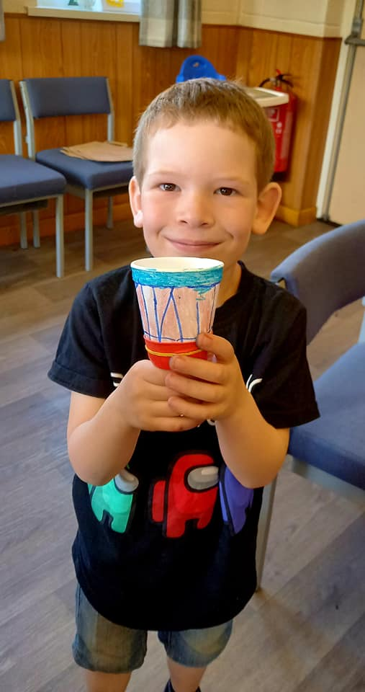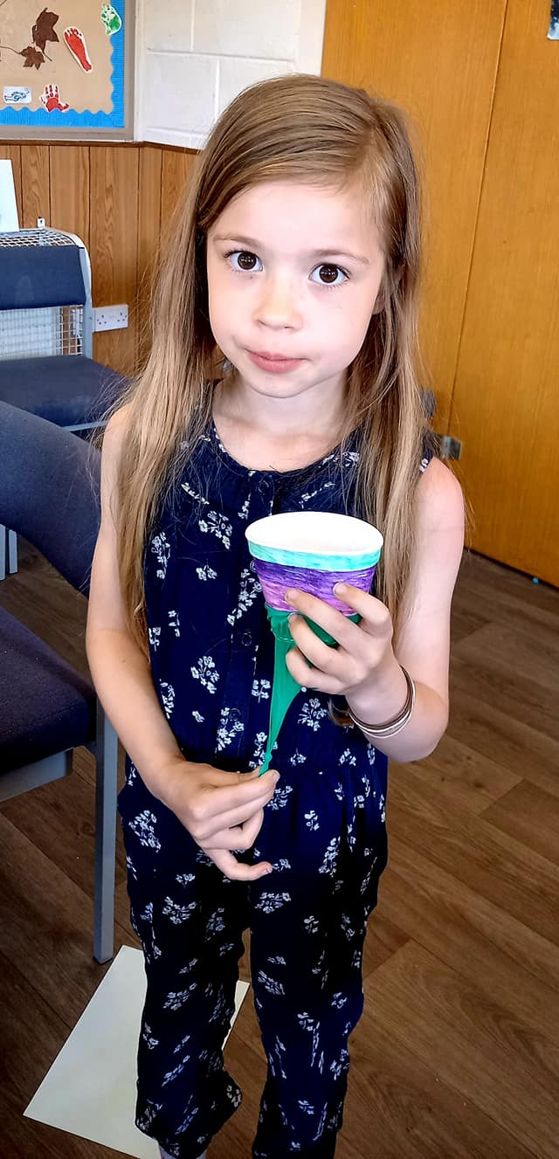

Family Challenge: Target Practice
You will need: some stones
Just like David had You will need to go outside for this activity, a smooth surface is best - be aware of others and make sure if you are not in your garden that people can safely pass you. Find a large stone and make it your target. You will each need to collect some stones, take it in turns to roll your stones towards the big stone, see who can get their stones the closest. Or why not have a go at learning crown green bowling – locally in Burnley you can learn for free as a family on a Sunday afternoon 1:30 – 3:30 based at Itenhill Park.
David would have had a lot of practice with his sling while he protected his sheep. What are some of the skills that God might want us to practice so that we can use them to serve Him?

A verse to remember: Psalm 9v9
The Lord defends those who suffer, he defends them in times of trouble.

Prayer:
Dear God, Thank you for the story of David who trusted and had faith in you. Help us to put our confidence in you and to be bold, knowing that you are with us. Help us to have a friendship with you like David did, to know you as a close friend who listens to us and hears our prayers. Help us to know you as sheep know their shepherd and trust in you to protect us and provide what we need. We pray for those facing big challenges during Lockdown that they would know you with them just like David did. Amen

