Sunday the 4th April The Empty Tomb John 20 v 1-18
How did Mary know that the person she met was Jesus? Mary did not realise at first who Jesus was, the Bible tells us that she thought he was the gardener. It was only when Jesus called her by name that she recognised him. This is the sort of relationship that God wants with each one of us – God knows each of us by name and loves us like a shepherd loves his sheep. Just like the sheep know the voice of their shepherd God wants us to respond to him and follow Him. When he died and rose again Jesus removed all the barriers that stood between us and God, all our mistakes were wiped away, the price was paid. Because of Jesus we can choose to follow God and to enjoy a perfect relationship with Him. Who is your best friend? What is your favourite thing about being friends with them?

Animation – Story
A short video about the Easter story https://www.youtube.com/watch?v=HL8R158Ujp4

Family Activity: Build a Easter Garden
Can you make your own Easter Garden? Gather items from your home, garden or from your daily walk to create your own Easter Garden together. You will need to select a stone to be in front of the tomb and roll away, a flowerpot or cup can make a good substitute for the tomb. You could do some junk modelling and use some items from your recycling or just build the whole thing from building blocks and toys. Once you have built your Easter garden, use any toy figures you have to act out the story of Easter morning together.

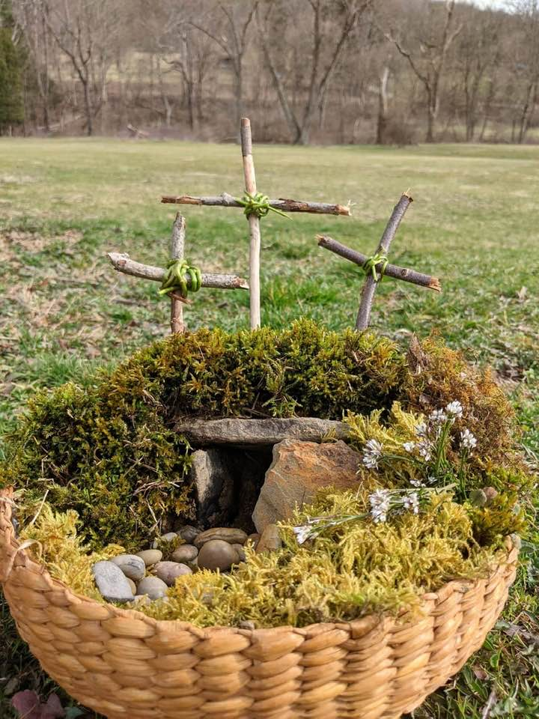

What about the eggs: There are lots of eggs at Easter, we can search for hidden eggs, decorate eggs or eat delicious eggs made from chocolate… but what can they teach us about the Easter story?

New life: Eggs are a symbol of birth and new life! We know Jesus was born as a baby on the earth, God in human form. Jesus was sent to be an example for us and to help us to be friends with God.

What’s inside: Traditional easter eggs are hollow inside, we can use this as a reminder of the tomb where Jesus was placed after he died. A large stone was placed in front of the tomb. When his friends visited the tomb, the stone had been rolled away and Jesus was gone, Jesus had come back to life! We believe that because Jesus died and came back to life there is hope for everyone.

A gift for every-one: We are all invited to be a friend of God and to one day be with Him in heaven. Who could you share this promise and story with today?

Family Activity – Baking
This next week at holiday club we are trying out each of these 3 baking activities why not give them a try yourselves?

Hot cross buns! Hot cross buns! One a penny, two a penny, Hot cross buns! If you have no daughters, Give them to your sons One a penny, Two a penny, Hot Cross Buns!
Hot cross buns are spiced sweet buns that are traditionally baked and eaten on Good Friday.

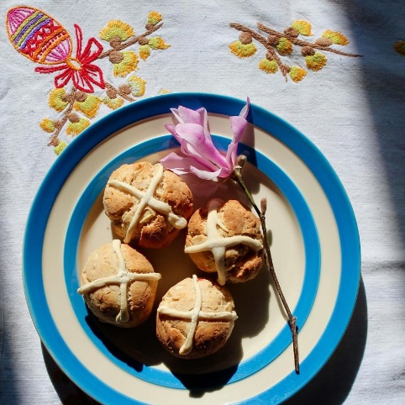

Traditional chocolate easter eggs are hollow inside, we can use this as a reminder of the tomb where Jesus was placed after he died. If you have a silicone egg template why not make and design your own chocolate eggs, maybe you could gift this to some-one?

Making these Homemade Resurrection Rolls is really a fun and delicious way to celebrate the true meaning of Easter with your family! Each ingredient in these Homemade Resurrection Rolls represents an important part of the resurrection story. The marshmallow represents Jesus’s body. Explain how Jesus died (Matthew 27:45-57) and why (John 3:16-17).

Jesus’ body was prepared for burial according to the Jewish customs of the time. The butter and cinnamon sugar mixture represent the oils and spices used to do this. Dip your marshmallows in butter and then roll them in cinnamon sugar. {John 19:38-42}. Discuss why Jesus needed to die and explain that we’re all sinners {Romans 3:23} and that the wages of sin is death {Romans 6:23}. In order for our sins to be forgiven a perfect sacrifice had to be made, and that was only possible in the death of Jesus. {2 Corinthians 5:21}.

The rolls {dough} represent the tomb. Put the marshmallow on the dough and then roll it up very tight. NOTE: You want to make sure there are no cracks or holes in your rolls, otherwise the marshmallow will ooze out. The tomb was heavily guarded and secure {Matthew 27:62-66}. The Romans put an enormous rock in front of the entrance to the tomb and assigned armed guards to keep watch outside. Emphasize how it would be impossible for a mere man to get in or out of the tomb. Put the Homemade Resurrection Rolls in the oven and explain that Jesus was in the tomb for 3 days {Matthew 12:40}. While the resurrection rolls are baking explain that God loved us so much that He sent His one and only son, Jesus, to come to earth and enter into our messy sinful lives. But He didn’t sin, He lived perfectly {John 3:16}. Jesus trades places with us, he was innocent and didn’t deserve any punishment, but He took our punishment of death. We are really the guilty ones and should be the ones who are “in the oven,” but Jesus took our place.

When you remove the empty tomb rolls from the oven discuss the resurrection! {Matthew 28:1-20}! Open the Homemade Resurrection Rolls to see that the marshmallow is GONE….just like Jesus’s body was no longer in the tomb when the women came to see him on Sunday. Discuss the importance of the resurrection in our lives and that salvation comes by grace alone through faith alone {Ephesians 2:8-9}! Explain that this whole story is called The Gospel, or “good news” and ask them to explain to us how Jesus’s death and resurrection is good news for them!

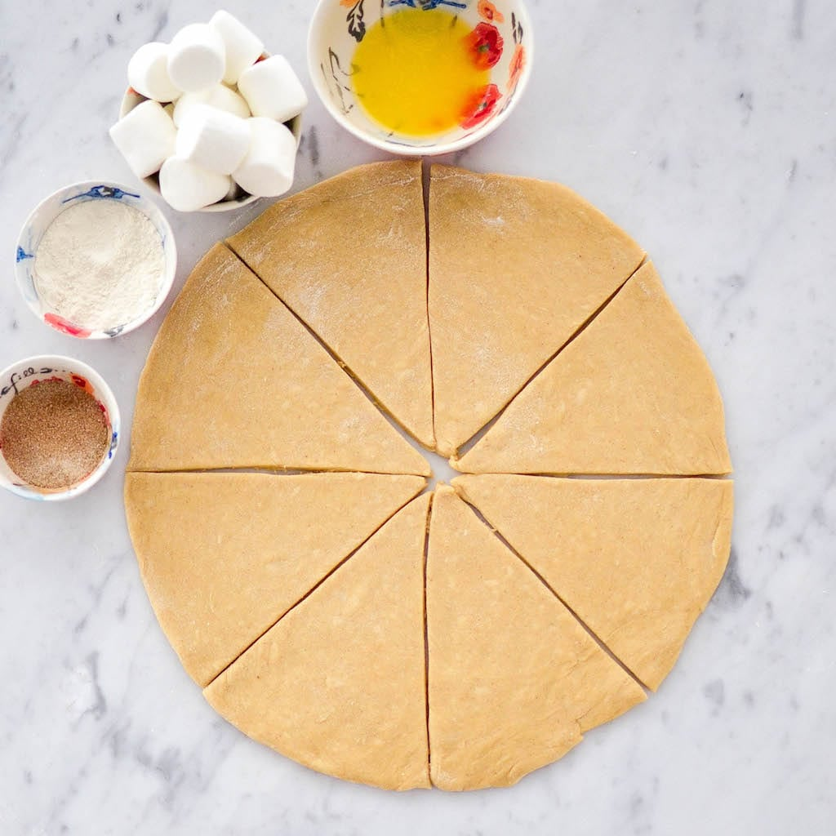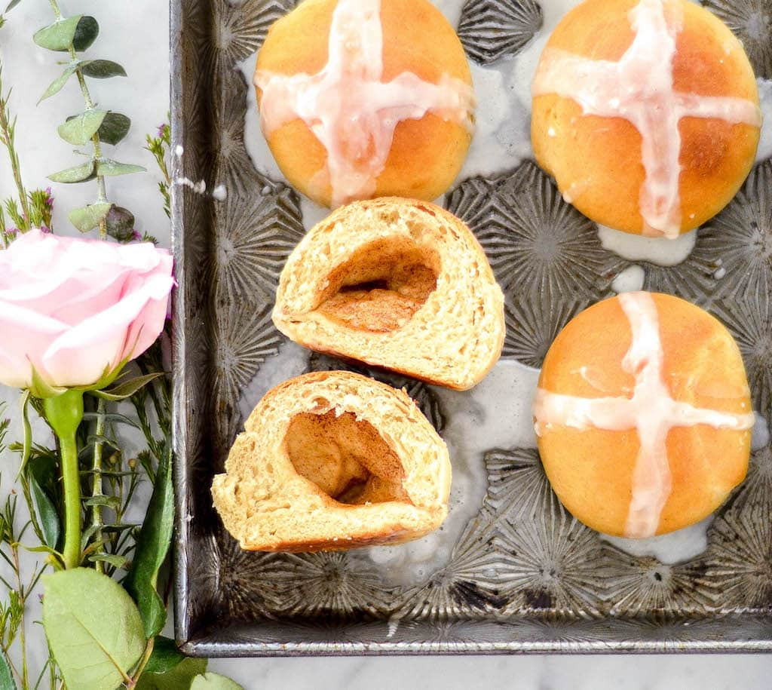

A verse to remember
Matthew 28 v 6 “He is not here; he has risen”!

Prayer
If you have never prayed a prayer of commitment asking Jesus to be your Saviour here is a simple prayer you can say today. Dear Jesus. Thank you that you came to earth and died on a cross to take the punishment that should have been mine. I am sorry for all the mistakes I have made and the times that I have lived selfishly. Today I accept your free gift of forgiveness and friendship and the promise of eternal life. I choose to live my life for you. Amen.

