Sunday 4th July: The story of David hearing about Saul’s death
Why do you think the people chose David to be King? How do you think David felt when he was chosen? The Bible describes David as a man ‘after God’s own heart’, David had shown he was a good leader and somebody who really cared for others. Many years before when Saul was King, Samuel had come to visit David and his family, he had anointed David with oil. David knew that a time would come when he would be King, that it was part of God’s plan, but it must have been positive to hear that he had been chosen by God’s people too
Can you think of a time when you had to lead others? What do you think makes a good leader?

Video to watch: https://www.youtube.com/watch?v=lZ7nDS07fO0

Family Craft: Nature Crown
Just like David we have been chosen to be royal – we are children of the King of Kings!
Why not have a go at picking some wild flowers and making your own Nature Crown.
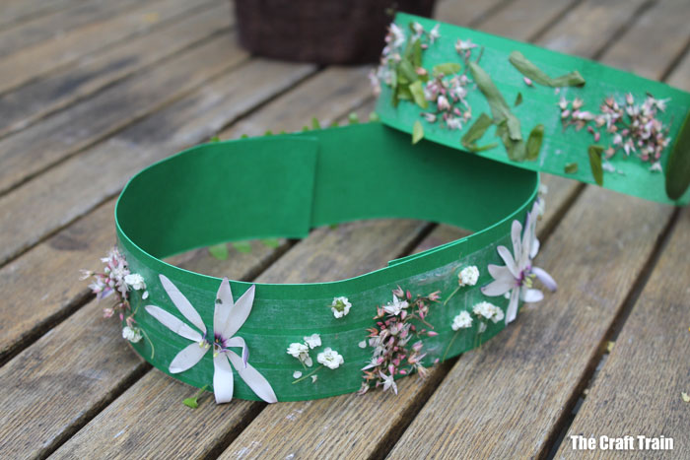

Family Challenge: Build a City
David build a palace inside the city of Jerusalem and many strong buildings for people to live in. Why not use building blocks, lego or other construction toys to design your own palace together. You might also like to create a fort using furniture, blankets and other household items

A verse to remember: Psalm 9v9
First we heard and now we have seen that God will always keep his city safe. It is the city of the Lord All-Powerful, the city of our God.

David wrote these words about the city of Jerusalem where he lived, he knew that God loved him and would give him protection. Why not pray and ask God to keep safe the people and placed that are most previous to you. Your home, church, school or town

Prayer:
Jerusalem is a real place that can still be visited today. Why not go on a virtual tour together using Google Street View and see what the City of David looks like today. While you explore the streets take time to pray for the people and places you see. • Pray for protection and safety for those living in Israel and the middle East. • Pray for an end to ongoing conflicts, for peace and reconciliation. • Pray for those in leadership that they would be good and loving shepherds to the people in their care.

Game: Pass the Crown
For this game you’ll need a crown. Use your hands, feet, elbows, head, roll it along the ground, throw it… keep going round the circle until it gets dropped and then start again. Link into God’ being in charge of who would wear the crown next not Saul!

