Story time – The story of the Angle visiting Mary! Luke 1 v 26-56
How do you think Mary felt when the angel told her that she was going to have such a special baby? Do you think Mary was a good choice?

Verse 29 tells us that even before Gabriel had told her about the baby, she was surprised by his greeting. Mary never expected to be chosen for a special task by God. Perhaps this is what made her such a good choice.

It must have been scary to be visited by an angel and to be given such a big important mission but Mary trusted in God and was obedient, saying “let this happen to me as you say.” These words are very similar to the ones that Jesus spoke in the garden of Gethsemane before going to the cross, perhaps God chose Mary because he knew that she would raise her son to be obedient and servant-hearted like she was.?

Family Game – God Says
Mary was obedient saying “I am the servant of the Lord. Let this happen to me as you say!”. Play a game of Simon says together, children might like to take it in turns to be the leader. You might
like to talk together about what it means to be obedient and to commit ourselves to serving God.

Family Activity Angle Craft
Use the template on the next page to make your own printable angel decorations. You could hang them on your tree or around the house as a reminder of this part of the story.

Family Activity 2 Magnificent Magnificat
Mary’s song of praise is known as the ‘Magnificat’. Work together as a family to write your own
song of praise together. You could use Mary’s song as a template.

Active Advent
Just like Mary we are invited to offer our lives to God in worship and service. God has a role and mission for each one of us. Why not take on these worship and service challenges during the second week of Advent, you could do one each day or do them all at once.
Dec 6th-Draw a picture of yourself in your dream job, what area of work would you like to serve God?
Dec 7th - Add to the picture to show you using a skill or talent that God has given you. How could you use that skill to serve and worship God today?
December 8th - Draw a heart on your picture, pray and ask God to help you be servant hearted, happy and willing to love and serve others.
December 9th - Add a house to your picture, what ways can you think of that you could serve others in your household today?
December 10th - Add a friend to the picture how can you serve them today and share God’s love with them?
December 11th - Write or draw some worship today, tell or show God what makes Him AMAZING!
December 12th - Ask God if there are any areas in your life where you could serve Him better or be more obedient.

A verse to remember – 1 Corinthians 1 v 8
Jesus will keep you strong until the end so that there will be no wrong in you on the day our Lord Jesus comes again.

Folding Paper Angels

Here’s what you’ll need:
2 pieces of paper, 21cm x 23cm (you can use any paper you like, we used sheet music)
1 natural bead with 2cm diameter (this bead is for the face, so we suggest using a pale pink/brown)
1 colorful bead with 1.5cm diameter (this is just to add a pop of colour) you can leave out this bead
50cm of string (ideally sparkly, if you have, but plain string would also do)
Stapler

Step 1: Fold one of the sheets of paper back and forth in concertina style, along the long side, with the folds being aprox. 1.5cm to 2cm wide.
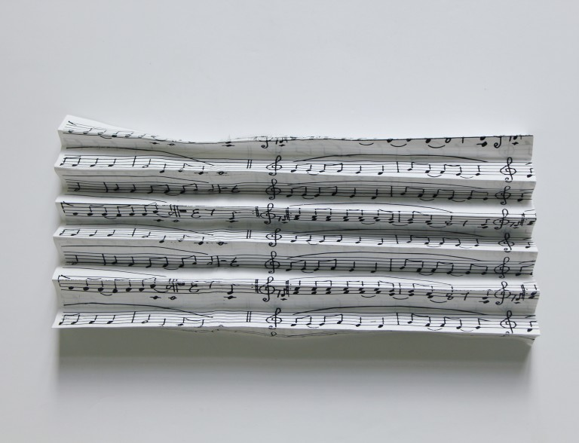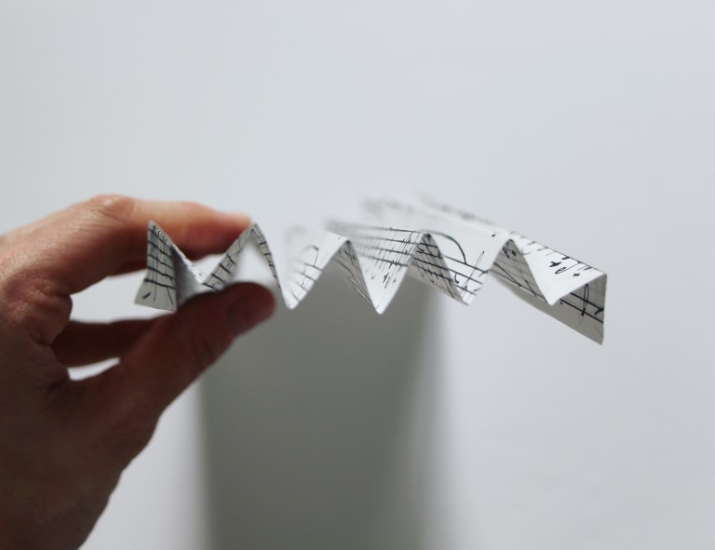
Step 2: Fold the top third of the paper sideways, as shown in picture 3 and staple it in place

Step 3: Repeat with the other sheet of paper.

Step 4: Fold the piece of string in half, to make a loop, and staple it to the side of one of the folded sheets of paper, with the loose ends pointing down. Then staple the two sheets of paper together – your angel should now look like this:

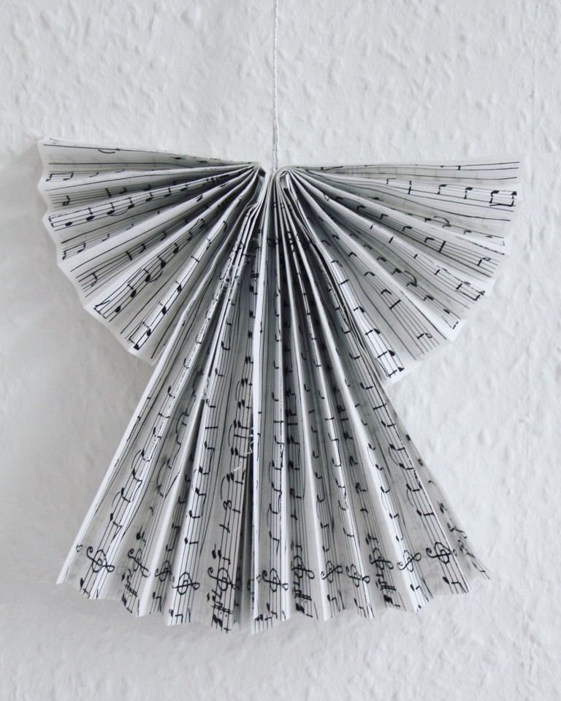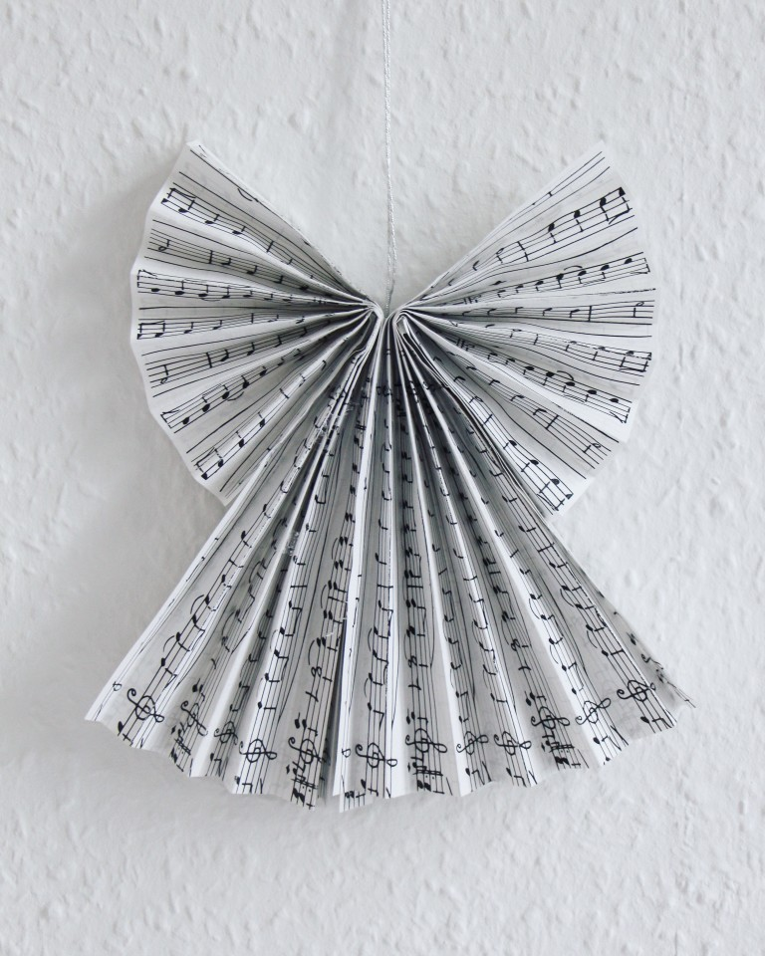
Step 5: Fan the top part of the folded sheets of paper out a bit, to create more fuller wings
Step 6: Finally, pop on the two beads, first the colourful one and then the plain/skin coloured one

