Sunday the 2nd of May - The vine and the branches John 15
What do you think it means to ‘remain in God’? and what do you think ‘God fruit’ looks and tastes like? God wants us to be connected to Him! Have you ever noticed that you have habits or phrases that you use because you have picked them up from the people around you? When we spend time with people, we can become more like them! When we spend time with God the same thing can happen. The branch of an apple tree connected to the trunk will produce apples! When we are connected to God and filled with His love that is the fruit we produce. We can bring a flavour of God and heaven to those we meet on the earth. The Holy Spirit in us helps us to produce good fruit. What are your favourite ways to show and share love with others?

Family Food Activity: Fruits of the spirit
“Does anyone know what type of a animal is on my picture? It looks like an apple! But actually, that’s Octi the Octopus. He’s smiling! Why do you think that is? It’s because Octi just accepted Jesus into his heart. Now Jesus is going to give him the fruits of the spirit! The fruits of the spirit are going to help him get around a little better. First, let’s pretend these fruits are magical, they contain some of God’s special blessings that Octi really needs.”

- “First, Octi needs JOY.” Take the green grapes and create one leg.
- “Second, Octi, needs PEACE.” Take the red grapes and create one leg.
- “Third, Octi needs PATIENCE.” Take the strawberries and create one leg.
- “Fourth, Octi needs KINDNESS.” Take the blueberries and create one leg.
- “Fifth, Octi needs GOODNESS.” Take the kiwi and create one leg.
- “Sixth, Octi needs FAITHFULNESS.” Take the banana and create one leg.
- “Seventh, Octi needs GENTLENESS.” Take the raspberries and create one leg.
- “Eighth, Octi needs SELF-CONTROL.” Take the peaches and create one leg.

“Now, what do you think? Can you tell he’s an octopus? Do you think he can get around now with all his beautiful fruit that Jesus gave to him? The fruits of the spirit work like this in us. They’re not really fruit. That’s just a word the Apostle Paul uses to get us thinking. They’re really wonderful character traits that we can have, once Jesus is in our hearts. If we call on Jesus to give us the fruits of the spirit, we’ll be able to get around in life a lot better! We’ll be filled with good things instead of bad, and the love of Jesus will always be with us! Speaking of LOVE that’s the ninth fruit of the spirit, Octi only has eight legs. Where’s the love? It’s in his heart because the love of Jesus is the first thing we feel when we ask him to come in!”

(In our house we have a pot of Chocolate for love and we can dip each of the fruits in Love!!!)

A verse to remember: 1 John 4 v19
“We love because God first loved us.”

Prayer
Thank you for the tree vine and the branches which reminds us to stay connected to you. Thank you that you love each one of us and want us to be part of your plans in the world. Help us to be producers of good fruit in the world, sharing your love with others so that they can come to know you too. Amen

Family Craft: The Vine and Branches God’s Fruit
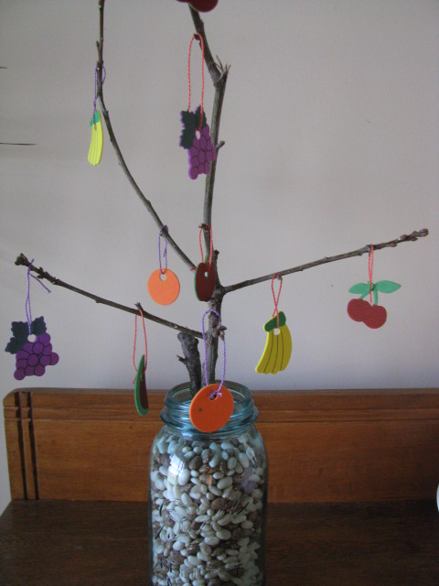
Place a tree-shaped stick in a jar/bucket of beans/rice/rocks.
Cut out fruit shapes from paper, card, foam sheets or anything else you like.
Punch a hole at the top of each fruit and loop ribbon, wool, or string through it to become a hanger.
Assign each type of fruit to one of the Fruits of the Spirit and write that name on the back of the fruits. For example, the apples might represent love, the bananas might represent joy, etc.
When a particular attitude/behaviour is displayed during the week, get the child to find the correct fruit to hang on the tree.
See if they can fill the tree with one of each fruit? You could add more fruits if they are doing really well!

